Near Synonyms

🔹 What is Near Synonyms
# Source: AI Source: Provided by: [Data Path: Persons Table -> ID Column: 1, Name_En Column: Motasem Essam] -> From: [Chatgpt (GPT-4-turbo)] on [7/30/2025]
Near synonyms (also called quasi-synonyms or approximate synonyms) are words that have similar but not identical meanings and may differ in tone, formality, intensity, or context.

🧠 Definition:
# Source: AI Source: Provided by: [Data Path: Persons Table -> ID Column: 1, Name_En Column: Motasem Essam] -> From: [Chatgpt (GPT-4-turbo)] on [7/30/2025]
Near synonyms are words with meanings that are close, but not exactly the same. They cannot be used interchangeably in all situations.
They usually belong to the same semantic field but carry subtle differences in:
- Emotion or tone
- Register (formal/informal)
- Typical usage (collocation)
- Strength or intensity

📌 Key Features:
# Source: AI Source: Provided by: [Data Path: Persons Table -> ID Column: 1, Name_En Column: Motasem Essam] -> From: [Chatgpt (GPT-4-turbo)] on [7/30/2025]
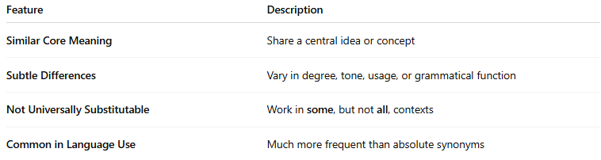
Feature | Description
Similar Core Meaning | Share a central idea or concept
Subtle Differences | Vary in degree, tone, usage, or grammatical function
Not Universally Substitutable | Work in some, but not all, contexts
Common in Language Use | Much more frequent than absolute synonyms

📚 Examples of Near Synonyms:
# Source: AI Source: Provided by: [Data Path: Persons Table -> ID Column: 1, Name_En Column: Motasem Essam] -> From: [Chatgpt (GPT-4-turbo)] on [7/30/2025]
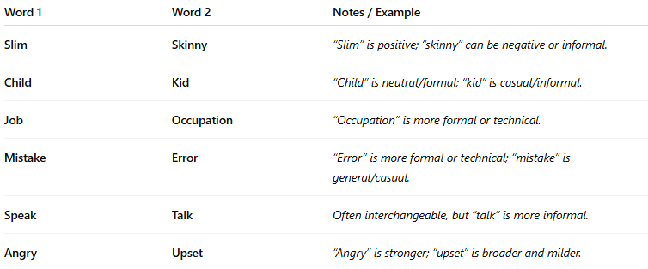
Word 1 | Word 2 | Notes / Example
Slim | Skinny | “Slim” is positive; “skinny” can be negative or informal.
Child | Kid | “Child” is neutral/formal; “kid” is casual/informal.
Job | Occupation | “Occupation” is more formal or technical.
Mistake | Error | “Error” is more formal or technical; “mistake” is general/casual.
Speak | Talk | Often interchangeable, but “talk” is more informal.
Angry | Upset | “Angry” is stronger; “upset” is broader and milder.

🔁 Near Synonyms vs Absolute Synonyms:
# Source: AI Source: Provided by: [Data Path: Persons Table -> ID Column: 1, Name_En Column: Motasem Essam] -> From: [Chatgpt (GPT-4-turbo)] on [7/30/2025]
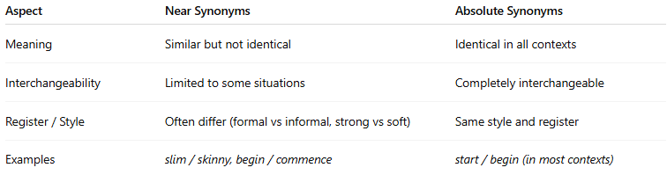
Aspect | Near Synonyms | Absolute Synonyms
Meaning | Similar but not identical | Identical in all contexts
Interchangeability | Limited to some situations | Completely interchangeable
Register / Style | Often differ (formal vs informal, strong vs soft) | Same style and register
Examples | slim / skinny, begin / commence | start / begin (in most contexts)

